Alternative views of Path Finding

Braydan Newman
n11272031

Summary

The motivation behind this case study is to provide a new perspective on understanding how Dijkstra's and A* path finding algorithms make decisions by visualizing their search processes through tree graphs rather than the traditional grid mazes. The main intention is to demystify these algorithms by representing their exploration and decision-making steps in an alternative format that can offer clearer insights into their operational differences and efficiencies.

The expected outputs are detailed visualizations of the algorithms' decision trees, highlighting the sequence of node expansions, path selections, and the influence of costs and heuristics on their choices. These visual representations aim to illustrate how each algorithm navigates through the search space, providing a side-by-side comparison that emphasizes their unique characteristics.

A novel aspect of the project is the shift from the classic grid maze visualization to tree graphs, which allows for a more intuitive understanding of the algorithms' inner workings. This approach sheds light on the hierarchical structure of their search processes and can reveal patterns and efficiencies not easily observed in grid-based representations. By offering this alternative view, the case study seeks to enhance educational tools and resources, making the concepts of path finding algorithms more accessible to learners and practitioners.

Project Description and Description of Tasks

This project aims to provide an alternative perspective on how Dijkstra's and A* path finding algorithms make their decisions by visualizing their search processes as tree graphs rather than the traditional grid mazes. The motivation is to enhance the understanding of these algorithms by representing their exploration and decision-making steps in a hierarchical tree structure. This approach can offer clearer insights into how the algorithms traverse the search space, select nodes, and ultimately find the optimal path.

Description of the data

The data being visualized consists of various graph structures that serve as the environments for the path finding algorithms. From a visualization perspective, the data includes:

- Nodes (Vertices):
  - Identifier: A unique label for each node. Coordinates: Position data if applicable, although in tree graphs, spatial positioning is less critical.
  - Accumulated Cost: The total cost from the start node to the current node.
  - Heuristic Estimate: For A*, the estimated cost from the current node to the goal node.
  - Parent Node: Reference to the predecessor node in the path.
- Edges (Links):
  - Weight (Cost): The cost associated with moving from one node to another.
  - Direction: Edges are typically directed in tree graphs, pointing from parent to child.

The graphs can be:
- Weighted Graphs: Edges have associated costs.
- Directed Trees: Hierarchical structures representing the search process.
Data Sources:
- Custom Graphs: Designed to illustrate specific scenarios, such as varying edge weights or particular node configurations.
- Standard Datasets: Utilized for more general cases, ensuring that the visualization techniques are applicable to typical use cases

Visualization Techniques
The project implements the following specific visualization techniques:

- Tree Graph Representation:
  - Transformation of Search Processes: Convert the search paths of Dijkstra's and A* algorithms into tree graphs, where each node represents a state in the search, and edges represent the transition to neighboring nodes.
  - Hierarchical Visualization: Display the nodes in a hierarchical layout, emphasizing the branching nature of the search and how different paths are explored.
- Animated Exploration:
  - Step-by-Step Visualization: Animate the expansion of nodes to show the order in which the algorithms explore the search space.
  - Highlighting Current Node: Emphasize the current node being explored to provide a clear understanding of the algorithm's progression.
- Interactive Features:
  - Node Interaction: Allow users to click on nodes to view detailed attributes such as accumulated cost, heuristic estimates, and parent nodes.
  - Comparison Tools: Enable side-by-side comparison of Dijkstra's and A* tree graphs to highlight differences in their search strategies.
- Visual Cues and Annotations:
  - Color Coding: Use different colors to represent various states (e.g., unexplored, open, closed nodes).
  - Annotations: Display textual information directly on the nodes or edges, such as cost values.

Tools

The project utilizes the following tools:
- Programming Language: Python - chosen for its readability and extensive ecosystem of libraries.
- Graphing Libraries:
  - Matplotlib: For creating static and interactive plots, including tree graphs.
  - Graphviz: Through the PyGraphviz interface, to generate detailed and customizable tree graph visualizations.
  - ETE Toolkit: A Python library specifically designed for analysis and visualization of tree structures, offering interactive tree visualization capabilities.
- Additional Libraries:
  - NetworkX: For creating and manipulating graph data structures, and for implementing the pathfinding algorithms.
  - PyGraphviz: Provides a Python interface to Graphviz, enabling integration with NetworkX.
  - NumPy/SciPy: For numerical computations if needed.

Progress to Date

Over the course of this project, significant progress has been made in exploring alternative views of path finding algorithms, specifically Dijkstra's and A*, by visualizing their decision-making processes through tree graphs rather than traditional grid mazes. Below is a detailed account of the work accomplished to date.

Background Research and Investigations

I began by conducting extensive background research on path finding algorithms, focusing on Dijkstra's and A*. This included studying their theoretical foundations, operational mechanisms, and common implementations. I reviewed academic papers, textbooks, and online resources to understand:
- The mathematical principles behind each algorithm.
- How heuristics influence the A* algorithm's performance.
- Previous visualization techniques used for these algorithms, particularly in grid-based environments.
Additionally, I investigated various data structures and graph theory concepts essential for transforming search processes into tree graphs.

Data Collection and Generation

To facilitate the visualization, I generated several graph datasets:
- Grid Graphs: Standard 2D grids representing maze-like environments, used for initial algorithm implementation and testing.
- Custom Graphs: Created graphs with varying complexities, including different node densities and edge weights, to challenge the algorithms and observe their behaviors in diverse scenarios.
- Tree Structures: Preliminary tree data structures to experiment with the visualization techniques.
The datasets include attributes such as node identifiers, positional coordinates, edge weights (costs), and heuristic values for the A* algorithm.

Data Manipulation

Data manipulation involved:
- Pre-processing Graph Data: Ensuring the graphs were suitable for both grid-based and tree-based representations.
- Attribute Assignment: Calculating and assigning heuristic values to nodes for the A* algorithm using functions like Euclidean and Manhattan distances.
- Transformation Functions: Developing preliminary functions to convert the algorithms' search processes from grid exploration into tree graph data structures, maintaining parent-child relationships.

Algorithms Studied and Applied
- Dijkstra's Algorithm: Implemented as the foundational algorithm for shortest path finding without heuristics.
- A*: Implemented with various heuristic functions to compare its efficiency and path selection against Dijkstra's algorithm.
I studied the impact of different heuristics on the A* algorithm's performance, including:
- Euclidean Distance: For environments where diagonal movement is allowed.
- Manhattan Distance: For grid-based environments with only orthogonal movement.

Code Development

I have written extensive code to implement the project:

- Algorithm Implementations:
  - Dijkstra's Algorithm: Implemented using Python and the NetworkX library, including modifications to record node expansion order and parent relationships.
  - A*: Similarly implemented with additional support for heuristic calculations.
- Data Structures:
  - Custom classes and functions to represent nodes, edges, and graphs.
  - Structures to store the search process data for transformation into tree graphs.
- Transformation Functions:
  - Functions to convert search paths into tree structures compatible with visualization tools like Graphviz and ETE Toolkit.
- Visualization Scripts:
  - Initial scripts using Matplotlib for plotting grid-based representations.
  - Prototype scripts using PyGraphviz to generate tree graph visualizations.

Visualization Packages and Techniques Used

Python Libraries:
- NetworkX: For graph creation, manipulation, and algorithm implementation.
- Matplotlib: For initial visualization of grid graphs and plotting algorithm progress.
- PyGraphviz: For creating detailed tree graph visualizations.
- ETE Toolkit: Experimented with this for interactive tree visualizations.

Visualization Techniques:
- Grid Visualization: Representing nodes and edges in a 2D grid layout, highlighting the path found by the algorithms.
- Tree Graph Visualization: Transforming the search process into a hierarchical tree structure to show the sequence of node expansions and decision points.
- Animated Exploration: Began developing animations to illustrate the algorithms' progression through the tree graph.

Visualization Outputs Produced

Grid-Based Visualizations:
- Successfully visualized the operation of Dijkstra's and A* algorithms on grid mazes.
- Highlighted the explored nodes, frontier, and the final path.

Preliminary Tree Graphs:
- Generated initial tree graphs representing the search process of both algorithms.
- Visualizations display parent-child relationships and the order of node expansions.

Comparative Visualizations:
- Began setting up side-by-side comparisons of the algorithms' tree graphs to observe differences in their search strategies.

Knowledge and Insights Gained

Algorithm Behavior:
- Observed that the A* algorithm, with an appropriate heuristic, explores fewer nodes than Dijkstra's algorithm, leading to more efficient path finding.
- Noted how the choice of heuristic affects the A* algorithm's performance and path selection.

Visualization Benefits:
- Realized that representing the search process as a tree graph provides clearer insights into the algorithms' decision-making.
- Tree graphs highlight the branching nature of the search and make it easier to see alternative paths considered by the algorithms.

Technical Challenges:
- Encountered challenges in accurately transforming the grid-based search process into a tree structure due to the inherent differences in representation.
- Gained experience in manipulating graph data structures and handling the complexity of visualizing large trees.

Next Steps

Refine Tree Graph Visualizations:
- Continue developing the transformation functions to produce more accurate and informative tree graphs.
- Enhance the visualizations with interactive features using ETE Toolkit or other suitable libraries.
Implement Interactive Elements:
- Add functionalities such as node clicking to display attributes and animations to show the progression of the algorithms.
Comparative Analysis:
- Complete the side-by-side visualizations and conduct a detailed analysis of the algorithms' behaviors using the tree graphs.
Documentation and Reporting:
- Begin compiling the findings and insights into the project report.
- Document the code and provide usage instructions for the visualization tools developed.

Conclusion

The progress made so far lays a solid foundation for the project's goals. Implementing the path finding algorithms on grid mazes has provided valuable insights and the necessary data to begin transforming their search processes into tree graphs. As I continue to develop and refine the tree graph visualizations, I anticipate that this alternative view will significantly enhance the understanding of how Dijkstra's and A* algorithms make decisions during path finding.

Proposed Tasks and Project Timeline

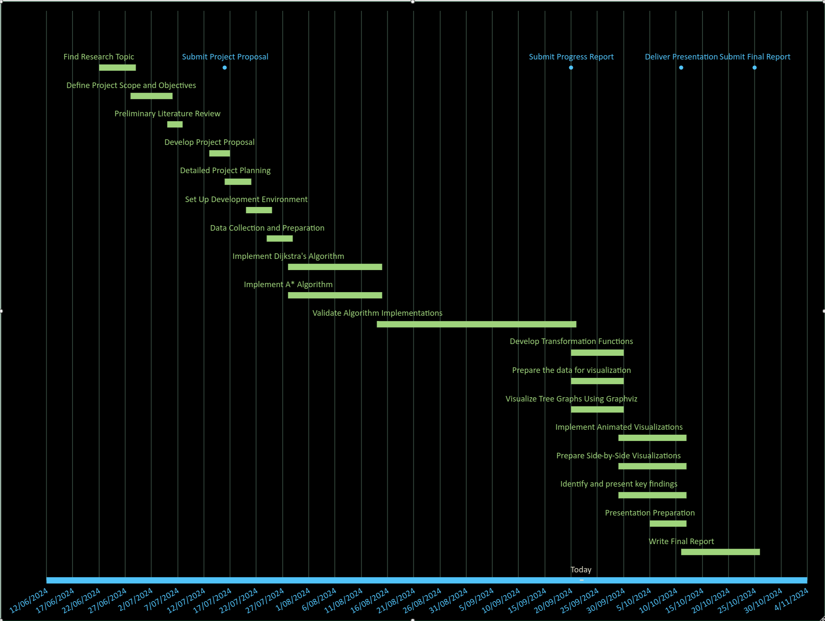

Foreseen Problems and Risks

Potential issues that may affect the project's outcomes include the technical complexity of converting grid-based path finding algorithms into tree graphs, which might lose spatial context and confuse users; visualization challenges due to large or complex tree graphs becoming cluttered and hard to interpret; possible coding errors impacting algorithm accuracy; time constraints leading to incomplete or rushed work; data limitations that don't reflect real-world scenarios; users finding tree graphs difficult to understand; integration and performance issues with multiple tools; steep learning curves for necessary technologies; and limited testing or feedback opportunities. To mitigate these challenges, the project should focus on core features, simplify visualizations, manage time effectively, seek early feedback, optimize code efficiency, thoroughly document work, and set realistic expectations.

References

Reference listBelwariar, R. (2018). A* Search Algorithm - GeeksforGeeks. [online] GeeksforGeeks. Available at: https://www.geeksforgeeks.org/a-search-algorithm.

GeeksforGeeks (2018). Dijsktra’s algorithm. [online] GeeksforGeeks. Available at: https://www.geeksforgeeks.org/dijkstras-shortest-path-algorithm-greedy-algo-7/.

Halim, S. (2024). Single-Source Shortest Paths (Dijkstra/+ve Weighted, BFS/Unweighted, Bellman-Ford, DFS/Tree, Dynamic Programming/DAG) - VisuAlgo. [online] visualgo.net. Available at: https://visualgo.net/en/sssp?slide=1.

Huerta-Cepas, J. (2016). ETE Toolkit - Analysis and Visualization of (phylogenetic) trees. [online] Etetoolkit.org. Available at: http://etetoolkit.org/ [Accessed 22 Sep. 2024].

Matplotlib (2012). Matplotlib: Python plotting — Matplotlib 3.1.1 documentation. [online] Matplotlib.org. Available at: https://matplotlib.org/.

NetworkX Developers (2024). Software for Complex Networks — NetworkX 2.8.8 documentation. [online] networkx.org. Available at: https://networkx.org/documentation/stable/.

Park, J. (2024). Algorithm Visualizer. [online] Algorithm Visualizer. Available at: https://algorithm-visualizer.org/.

Red Blob Games (2014). Red Blob Games: Introduction to A*. [online] Redblobgames.com. Available at: https://www.redblobgames.com/pathfinding/a-star/introduction.html.

